The Story Behind the Numbers: Measuring the
Impact of Networked Electronic Services (MINES) and the Assessment of
the Ontario Council of University Libraries' Scholars Portal
6th Northumbria International Conference on Performance Measurement in Libraries and Information Services
The impact and outcomes of library and information services: Performance measurement for a changing information environment
22nd – 25th August 2005 – Colllingwood College, Durham, UK

Martha Kyrillidou, Director of the ARL Statistics and Measurement Program, Association of Research Libraries <martha@arl.org>
Toni Olshen, Business Librarian, Peter F. Bronfman Business Library, York University <tolshen@YorkU.CA>
Brinley Franklin, Vice Provost for University Libraries, University of Connecticut <Brinley.Franklin@uconn.edu>
Terry Plum, Assistant Dean, Simmons Graduate School of Library and Information Science <terry.plum@simmons.edu>
Abstract
The Ontario Council of University Libraries (OCUL) launched the Scholars Portal in 2001. The Portal provides access to networked electronic resources purchased consortially by twenty Ontario Universities. The assessment team at OCUL has partnered with the Association of Research Libraries Statistics and Measurement Program to use the innovative survey methodology: Measuring the Impact of Networked Electronic Services for Libraries (MINES for Libraries™) to assess the impact of the Scholars Portal on the academic community in sixteen Ontario libraries. MINES for Libraries™ is an online transaction-based survey that collects data on the purpose of use and demographics of electronic resource users. This paper describes the evolution of MINES for Libraries™ as a new survey method adapted from earlier well-established approaches, discover how the evaluation process unfolded with the OCUL implementation, and hear about the OCUL/MINES survey results.
Introduction
As libraries implement access to electronic resources through portals, collaborations, and consortium arrangements, the MINES for Libraries™ protocol offers a convenient way to collect information from users in an environment where they no longer need to physically enter the library in order to access resources (Franklin and Plum, 2004, 2003, 2002). MINES for Libraries™ adapts a long-established methodology to account for the use of information resources in the digital environment. The survey is based on methods developed to determine the indirect costs (Franklin, 2001) of conducting grant-funded R&D activities, and was adopted as part of ARL’s New Measures program in May 2003.
Ontario Council of University Libraries (OCUL)

The Ontario Council of University Libraries (OCUL) is a consortium of twenty publicly-funded university libraries in the province of Ontario. The member libraries cooperate to enhance information services through resource sharing, collective purchasing, document delivery and many other similar activities. Funding from a government initiatives fund, the Ontario Innovation Trust (OIT), was instrumental in the creation of the Ontario Information Infrastructure (OII) Scholars Portal. OCUL received $7.6 million for the start-up period of 2000-2005. Beginning in 2006, OCUL universities will share the cost of the Scholars Portal.

In 2001, OCUL created the Scholars Portal, an information infrastructure to support digital content which delivers resources for research, teaching and learning to the province’s universities. The Scholars Portal includes a number of core services that are shared by all members. The project goals for the electronic resources component of OCUL services are:

- Centrally mounting and delivering information resources acquired through OCUL consortia purchases to ensure rapid and reliable access, and secure archiving.
- Ensuring that the resources and services provided by the OII address the needs of faculty, students and staff.
- Ensuring that resources and services can be seamlessly integrated to the local library and information systems of the institution.
In January 2004, the evaluation phase of E-Journal@Scholars Portal the electronic journals project began.
John Cotton Dana, a key figure in 20th century librarianship, wrote in 1920:
“All public institutions…should give returns for their costs; and those returns should be in good degree positive, definite, visible and measurable […] Common sense demands that a publicly-supported institution do something for its supporters and that some part at least of what it does be capable of clear description and downright valuation.”
To meet that imperative, (OCUL) applied the innovative measurement survey tool, Measuring the Impact of Networked Electronic Services (MINES), to this multi-library multi-million dollar province-wide electronic resources project to measure its success and impact on the users of Ontario’s academic libraries. The Ontario universities are public institutions and therefore have a responsibility to provide government funders and campus stakeholders with measurable evidence that the resources and efforts poured into the Scholars Portal have resulted in meeting the projects goals and constituents’ expectations.

Table 1 shows the OCUL member libraries and the number of full-time equivalents (FTE) students enrolled in each institution. Approximately 10% of these are graduate students.

These institutions span a wide spectrum with differences that impact the nature of their collections and services as well as the electronic journal usage patterns of their students, faculty and staff: The newest member, the University of Ontario Institute of Technology, was incorporated in September 2004 with 900 students and has a collection of 150,000 volumes while the University of Toronto, which began in 1827, has over 60,000 students and library holdings of over 9,800,000 volumes; the community sizes vary from a town of 53,000 in northern Ontario to Toronto, Canada’s largest city, with a core population of almost 3 million; some of the libraries are special libraries such as an art and design college and a military college; the consortium includes seven ARL libraries; there are six institutions with medical schools and six with law schools; some are small institutions with predominantly residential campuses while York University, for example, has over 40,000 students with only 8% living on campus; Toronto is home to three of the universities, while Kingston, Ottawa and Waterloo each house two OCUL institutions; and three universities are officially bilingual with English and French mandates.

All consortia members dip into the same pool of quality electronic resources. E-Journals@Scholars Portal covers most disciplines, with a concentration in the sciences, but with growing social sciences and humanities content. It is one of the largest collections of electronic journals available to researchers anywhere. Technical and developmental support is provided by OCUL staff housed at the University of Toronto, which acts as OCUL’s service provider. As of July, 2005, the Scholars Portal contains 8.2 million articles from 7,219 full text electronic journals from the following publishers which are locally loaded on to an OCUL server at the University of Toronto:

- Academic Press,
- American Psychological Association,
- American Chemical Society,
- Berkeley Electronic Press,
- Blackwell Publishing
- Cambridge University Press,
- Emerald Publishing,
- Elsevier Science (Elsevier Science, Harcourt Health Sciences),
- IEEE Publication,
- Kluwer (Kluwer Academic Publishers, Kluwer Law International and Kluwer/Plenum),
- Oxford University Press,
- Project MUSE,
- Sage Publications,
- Springer-Verlag,
- Taylor and Francis
- John Wiley & Sons.

The MINES for LibrariesTM Methodology

MINES for LibrariesTM is a research methodology that been used to measure which networked electronic resources of a library or consortium are utilized by a specific category of the patron population (e.g., patron status or university departmental affiliation). It also solicits the patron’s location at the time of use, and the purpose of use.

MINES for LibrariesTM is different from other electronic resource usage measures that quantify total usage, such as Project COUNTER and the Association of Research Libraries’ E-metrics initiatives, or how well a library or consortium of libraries makes electronic resources accessible, such as ARL’s DigiQualTM or LibQual+ TM. MINES for LibrariesTM was adopted by the Association of Research Libraries as part of the “New Measures” toolkit in May, 2003. The primary difference between the MINES for LibrariesTM approach and many of the other web-based user surveys is the emphasis on usage. Although user demographic information is collected, the web survey is really a usage survey, not a user survey.

The sampling methodology employed in the Scholar’s Portal assessment project is a random moments sampling technique that surveyed Scholar’s Portal users during a twelve month period using one randomly selected two hour survey period each month.
Because OCUL maintains detailed Scholar’s Portal usage statistics that tracks usage by time of day, we were able to weight the choice of two hour time periods so that periods of higher use received a higher proportionate likelihood of being selected as a survey period time. The OCUL usage statistics are similar to vendor supplied frequency data for sessions, searches, and views, but they are commensurable across different vendors, and are broken out by institution.

From electronic resource usage data collected in five previous MINES surveys, a statistician, Uwe Koehn, reported that, in the electronic environment, the sample size (n) required for accuracy (A) is n=1/A² (Koehn, 2003). Koehn also recommended stratifying survey periods throughout the year, as was done in the OCUL Scholar’s Portal study. Based on Koehn’s calculations a twelve period, or twenty-four hours per year, sampling plan was employed for the OCUL Scholar’s Portal survey. Data was collected from sixteen OCUL libraries, comprising more than 20,000 uses, between May, 2004 and April, 2005.

During the one randomly selected two hour survey period each month, all Scholar’s Portal users were presented with a brief web-based survey form each time they accessed a networked electronic resources offered through OCUL’s Scholar’s Portal. The respondent had to choose or select the resource in order to be presented with the survey, therefore memory or impression management errors were avoided. Once the survey is completed, the respondent’s browser was forwarded to the desired networked electronic resource. Participation in the survey was mandatory in order to connect to the electronic resource being sought by a user. Because the random moments sampling technique requires samples of only a very small time period (two hours per month), it was important to obtain as high a response rate as possible during the sample period. An ongoing study at another library seems to show that voluntary participation in the survey, or a sample of a sample, does not yield as representative an estimate of total usage as a sample requiring all users to participate. (Franklin and Plum, 2005, unpublished data)

Technically, the Scholar’s Portal presented some unusual challenges, which were overcome by Alan Darnell and Vidhya Parthasarathy, who comprised the University of
Toronto OCUL technical group for this project. The Scholar’s Portal resources are accessed from web pages within each library either through direct links to the ejournal titles as presented on various lists of e-resources, direct links to the ejournal titles through records in the online catalog, or prominently displayed links to the Scholars Portal home page on the library’s web site. Electronic journals are authenticated by Internet Protocol (IP) address, but the Scholar’s Portal also restricts by IP. Most member libraries have a proxy server; primarily, but not exclusively, EZProxy.

Once in Scholar’s Portal, there is a search function which retrieves journal articles, and a browse function retrieving journal titles. Roughly, 60% of the usage was through browse, and the remaining 40% was through the search feature, based on Scholar’s Portal frequency of use data. For this reason, the survey was placed at the point of viewing an article. Intercepting the library patron at the article view solved the problem of trying count usage of journal titles and journal articles as though they were the same. Surveying at the article view also made consistent the survey intercept for all libraries, so that those libraries emphasizing browsing of titles would not have different results from those libraries which chose to highlight the search function on the Scholar’s Portal home page. In the case of repeated usage by the same user (that is, the same workstation) the survey auto-populated, using a cookie, retaining the values for the previously completed survey. This strategy captured repeated usage and lessened the potential for annoying the patron.

The Scholar’s Portal technical group used perl scripts and CGIs to provide access to resources, and the survey was written using same these techniques. MINES has followed the web survey design guidelines recommended by Dillman (2000), which suggests fourteen principles for the design of web surveys to mitigate the traditional sources of web survey error: sampling, coverage, measurement and non-response. To reduce the effects on the respondents of different renderings of the survey by different workstation browsers, the survey used simple text for its questions. The survey is short, with only a few questions, easy to navigate, and plain. In addition to the values of the questions to which the users responded, the record for each surveyed usage included a time and date stamp, the IP address of the client workstation or proxy server, the referring URL, the destination or target URL, and the institution with which the patron was affiliated. The IP address was used to identify the institutional affiliation of the surveyed patron. ISSNs are part of the target file structure, and so could be broken out, easily identifying the target ejournal.

MINES SURVEY at OCUL

The focus of the MINES survey was this electronic journals component of the Scholars Portal. The aim was to evaluate how well Ontario university libraries were meeting researcher needs with the consortia-purchased electronic resources offered.

The desired outcomes in utilizing the MINES survey methodology were:

- To capture in-library and remote web usage of Scholars Portal in a sound representative sample using MINES methodology

- To identify the demographic differences between in-house library users as compared to remote users by status of user (presently we cannot get user status from our Scholars Portal usage data).

- To identify users’ purposes for accessing Scholars Portal electronic services (funded research, non-funded research, instruction/education use, student research papers and course work) to assist with the evaluation of the project ( as well as to broaden the scope to capture information for OCUL about indirect research costs.)

- To develop an OCUL infrastructure to make studies of patron usage of OCUL networked electronic resources routine, robust and integrated in to the decision-making process.

History of OCUL Involvement and Survey Implementation

OCUL used a customized version of the MINES instrument and methodology previously employed at five academic health sciences libraries and two large main academic libraries in the United States. These studies were designed and conducted by Brinley Franklin (University of Connecticut) and Terry Plum (Simmons Graduate School of Library and Information Science).

MINES for Libraries™ came to OCUL’s attention in 2003 after it was incorporated into ARL’s New Measures Initiatives. The OII Project Management Team was excited about the MINES project because of its potential to provide OCUL with unique information about actual Scholars Portal use that was not achievable through other means. . In the fall of 2003, an agreement was signed with ARL to work on a joint project in implementing the MINES survey for OCUL libraries.

Details were worked out with the key people at the University of Toronto responsible for running the methodology for the seventeen OCUL institutions which had computing environments that would sustain the application of the survey. ARL prepared a schedule for random two-hour monthly runs of the survey. A year’s worth of data would be collected that would span all times of the day and night and academic sessions. It was recognized that the methodology was unorthodox in that it included a mandatory element that might be problematic. It was also acknowledged that the survey might be annoying for patrons who were retrieving a large number of electronic journals during the same two-hour sample period, and therefore would be repeatedly surveyed. However, it was agreed that the benefits of rigorous data collection were great and every effort was made to minimize user inconvenience, including an immediate automatic connection to the resource of choice, and an auto-populated form if a user was accessing more than one journal in succession.

Several OCUL libraries mounted web pages or produced newsletter articles explaining the project, its methodology, and benefits. In order to accommodate the needs at the three bilingual institutions in the province, the survey form and the explanatory material were translated into French. Each survey participant was given a choice of language on the survey form. A test run was planned at York University and Wilfrid Laurier University in January 2004. The pilot failed at York and highlighted the need for all institutions to be using a consistent link resolver URL when connecting to the Scholars Portal from their catalogues or eResources databases. Each site reviewed their configuration and necessary changes were made. Due to technical problems including a server disruption, the February and March runs were considered tests and the April run was cancelled. The real data collection ran from May 2004 through April 2005.

The February and March runs of the survey highlighted the different ways OCUL libraries implemented and accessed the Scholars Portal. That variety needed to be reflected in the data gathering. As originally planned, the data gathering was revised to capture every journal usage during the two- hour survey periods coming from :
  - local electronic resources databases
  - library catalogues
  - Scholars Portal browse and search functions.

OCUL employed a unique definition of usage which was possible since article-level data was archived on an OCUL server: a successful search was defined as connecting the user to an article of interest for viewing, downloading or printing. The figure below shows the survey form as it appeared on the web.

Figure 1:OCUL MINES for Libraries™ Survey Form
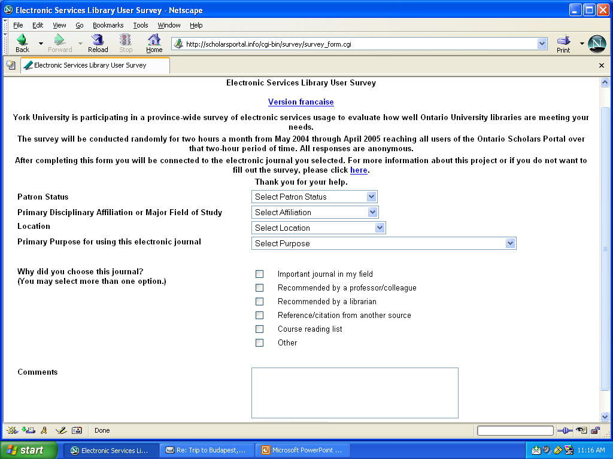

Benefits of the Methodology

The methodology is based on an attempt to capture every user of the service. Without a random sampling plan, in which each user has an equal chance of being included in the sample, we cannot really say anything about the population from which the sample is drawn. The sample based on random moments permits OCUL to make reliable inferences about the population, and to test hypotheses. The random sampling plan and the mandatory nature of the questions are both required to create a statistically sound study. If the survey is not mandatory, the group of non-respondents is likely to be different from the group of respondents, and we will not know what that difference is. One of the strengths and innovations of this survey technique is that it is based upon actual use, not on predicted, intended, or remembered use.

Ethics Review

All Canadian Universities must comply with the Tri-Council Policy Statement on Ethical Conduct for Human Research Involving Humans 1998 (Updated 2000, 2002 http://www.ncehr-cnerh.org/english/code_2/) put out by the Medical Research Council of Canada, the Natural Sciences and Engineering Research Council of Canada, and the Social Sciences and Humanities Research Council of Canada. The next major step in implementing the MINES survey in each of the seventeen eligible libraries was contacting research ethics officers and/or Ethics Review Boards to get approval to run the survey.

The purpose of ethics reviews for human subjects is to prevent putting subjects at risk. In the document, “the standard of minimal risk is commonly defined as follows: if potential subjects can reasonably be expected to regard the probability and magnitude of possible harms implied by participation in the research to be no greater than those encountered by the subject in those aspects of his or her everyday life that relate to the research then the research can be regarded as within the range of minimal risk.” The mandatory nature of the survey required some discussion on some campuses. OII contacts and/or the Directors were involved in this process and interacted with the necessary people to facilitate approval. It was argued that if individuals chose to avoid filling out survey, they might be inconvenienced for a maximum of a two-hour period, but they would not be harmed. OCUL opted in favor of the need for good data for decision-making over the possible inconvenience caused to the user.

The people responsible for these decisions on sixteen OCUL campuses understood that no physical or psychological harm will come to library users who are asked to fill out a brief anonymous survey before they are connected to the title of their choice. Under the MINES for Libraries™ methodology, the possibility of this happening would take place over a random 24 hours a year divided into two-hour periods every month from May 2004 through April 2005. Eight campuses did not require approval because the survey fell into quality assurance guidelines and was seen as a library management tool; eight received approval after an application process. One library did not receive approval due to the mandatory nature of the survey. It was determined that it was preferable to go with statistical valid data from the large number of OCUL libraries (sixteen out of seventeen) able to participate rather than stray from the benefits of the methodology.

Other Assessment Tools

The Survey presented five questions and a comments box for real-time user feedback. The comments about the Scholars Portal provide useful qualitative data. The findings of the MINES for Libraries™ survey will be complemented by journal usage statistics maintained by the University of Toronto (see Figure 2 below), qualitative feedback gathered directly for students and faculty, and an email staff survey. The purpose of the focus groups which were held on six OCUL campuses was to hear user views about the Scholars Portal, how students and faculty use it, the impact it has had on their research, and suggested enhancements. Also, a staff survey was conducted to learn lessons about how the Scholars Portal was implemented and integrated in to the library activities on each OCUL campus and why the Scholars Portal has been more successful on some campus than at others. Figure below shows the Scholars Portal Report Generator.

Figure 2. Scholars Portal Usage Report Generator

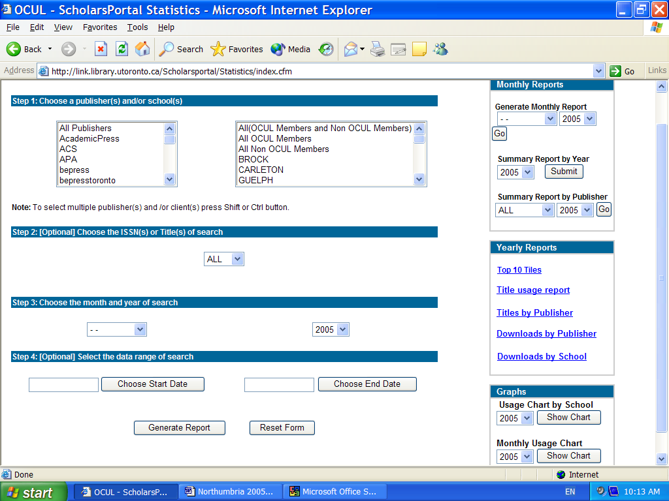

Survey Findings

A total of 22,946 cases were collected through the MINES for Libraries ™ evaluation of the OCUL Scholars Portal survey during the period May 2004 to April 2005. Detailed analysis of all of the variables for all institutions was presented to OCUL. In addition to this analysis, an interactive analysis of the data with specific institutional level tables is presented through StatsQUAL™ -- a gateway to library assessment tools. MINES for Libraries™ is one of these tools in the StatsQUAL™ interface and is accessible by OCUL libraries through a password protected interface at: http://www.statsqual.org/mines/index.cfm
Figure 3 presents an web page that demonstrates the analytical interface ARL has created for the OCUL MINES for Libraries™ project.

Figure 3. MINES for Libraries™ through the StatsQUAL™ gateway

The MINES for Libraries™ database is a rich resources for all sixteen OCUL institutions that participated in this study. The analysis presented here can cover only a basic approach which is expected to be enhanced locally by the participating libraries. It highlights only a select number of findings from the perspective of the analysts at the Association of Research Libraries Statistics and Measurement Program.

A number of respondents left partially missing data for Affiliation, User Status, Location and Purpose of Use. There were 20,293 complete responses though and Table 2 presents the distribution of the respondents on these key variables. The subject affiliation of the majority of the respondents is science comprising 23.2% (4,698 respondents), closely followed by medical health (21.6%), social sciences (19.2%) and applied sciences (14.4%). Close to half of the respondents are undergraduates (45.9%), followed by graduate professionals (32.3%), and faculty (11.1%). Most respondents use these resources from off-campus (45.1%), next from on campus locations but outside the library (34.9%) and only 19.9% of them use electronic resources from within a library building. And, the primary purpose of use of these resources is coursework (42.6%), followed by sponsored research (26.2%), and other research activities (16.2%).

Analysis is currently ongoing and a final report to the OCUL members will be available through the MINES for Libraries™ website. The goal is to inform decision making for future funding of these resources and a sense of perceived value based on use across different user categories. .

References

Dillman, D.A. 2000 (December). Mail and Internet Surveys, The Tailored Design Method. 2nd Ed. New York: John Wiley & Sons.
Franklin, Brinley and Terry Plum. 2004. “Library usage patterns in the electronic information environment.” Information Research, 9(4), paper 187.
http://informationr.net/ir/9-4/paper187.html
Franklin, Brinley and Terry Plum. 2003. “Documenting Usage Patterns of Networked Electronic Services.” ARL Bimonthly Report, No. 230/231 (October/December): 20-21. http://www.arl.org/newsltr/230/usage.html
Franklin, Brinley and Terry Plum. 2002. “Networked Electronic Services Usage Patterns at Four Academic Health Sciences Libraries.” Performance Measurement and Metrics 3(3): 123-133. http://www.emeraldinsight.com/1467-8047.htm
Franklin, Brinley. 2001. “Academic Research Library Support of Sponsored Research in the United States.” Proceedings of the 4th Northumbria International Conference on Performance Measurement in Libraries and Information Services. Association of Research Libraries, Washington, D.C. http://www.libqual.org/documents/admin/franklin.pdf
Koehn, Uwe. 2003. Personal communication. (June 15).

Table 1. Ontario Council of University Libraries
July 2005
Partner Institutions | FTEs
Brock University | 13,691
Carleton University | 19,574
University of Guelph | 18,082
Lakehead University | 6,738
Laurentian University | 7,505
McMaster University | 20,497
Nipissing University | 4,285
Ontario College of Art and Design | 2,717
University of Ontario Institute of Technology | 900
University of Ottawa | 26,893
Queen's University | 18,877
Royal Military College of Canada* | 1,941
Ryerson University | 20,990
University of Toronto | 60,456
Trent University | 6,726
University of Waterloo | 22,765
University of Western Ontario | 31,336
Wilfrid Laurier University | 11,306
University of Windsor | 14,577
York University | 40,899
*2002
Total | 350,755

Table 2. Frequencies by Affiliation, User Status, Location, Purpose of Use
Affiliation | Percent
Applied Sciences | 14.4%
Business | 4.0%
Education | 4.3%
Environmental Studies | 4.3%
Fine Arts | 0.8%
Humanities | 3.0%
Law | 0.6%
Medical Health | 21.6%
Other | 4.7%
Sciences | 23.2%
Social Sciences | 19.2%
Total | 100.0%
Affiliation | Frequency
Applied Sciences | 2930
Business | 814
Education | 881
Environmental Studies | 867
Fine Arts | 160
Humanities | 600
Law | 117
Medical Health | 4391
Other | 948
Sciences | 4698
Social Sciences | 3887
Total | 20293
User Status | Frequency
Faculty | 2261
Graduate Professional | 6545
Library Staff | 328
Other | 721
Staff | 1128
Undergraduate | 9310
Total | 20293
User Status | Percent
Faculty | 11.1%
Graduate Professional | 32.3%
Library Staff | 1.6%
Other | 3.6%
Staff | 5.6%
Undergraduate | 45.9%
Total | 100.0%
Location | Frequency
Library | 4047
Off-Campus | 9158
On-Campus | 7088
Total | 20293
Location | Percent
Library | 19.9%
Off-Campus | 45.1%
On-Campus | 34.9%
Total | 100.0%
Purpose of Use | Frequency
Coursework | 8530
Other Activities | 1523
Other Research | 3290
Patient Care | 487
Sponsored | 5318
Teaching | 1145
Total | 20293
Purpose of Use | Percent
Coursework | 42.0%
Other Activities | 7.5%
Other Research | 16.2%
Patient Care | 2.4%
Sponsored | 26.2%
Teaching | 5.6%
Total | 100.0%

John Cotton Dana. The New Museum: Selected Writings by John Cotton Dana, edited by William Penniston (1999). Quoted in The 2003 OCLC Environmental Scan: Pattern Recognition in chapter “The Economic Landscape”, Online Computer Library Centre, (Dublin Ohio: OCLC, 2004):30.

